AGENDA - Little Hoole Parish Council  Members of the Council are summoned to the Parish Council Meeting to be held on  Mon 11th May 2026 at 7:15pm  The Lounge, Walmer Bridge Village Hall, Gill Lane, Walmer Bridge, PR4 5GN  Paul Cafferkey, Clerk & Responsible Financial Officer | 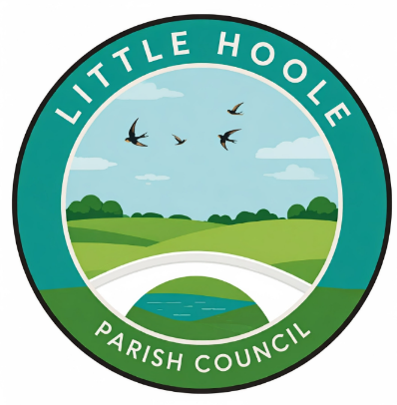
- Apologies for absence
- To agree the Minutes of the last Parish Council Meeting held on the 13th April 2026.
- To receive declarations of interest.
- Matters arising from the minutes of last meeting.
  - Public Time: to invite and listen to issues raised by members of the public.
  - To consider the following Planning Applications:
    - 07/2026/00292/HOH. Brookroyd Gill Lane Longton PR4 5GN. Raising of ridge height and rotation of roof 90-degrees to create first-floor accommodation with gable roof and single storey rear extension.
    - 07/2026/00262/CLD. 83 Tillage Close Walmer Bridge PR4 5BZ. Certificate of Lawfulness for a garage conversion.
    - 07/2026/00274/HOH. 17 Dob Lane Walmer Bridge PR4 5QL. Loft conversion (front and rear dormer extensions) and new front porch. Render whole building.
    - 07/2026/00246/DIS. West Field Moss Lane Little Hoole PR4 4TA. Discharge of condition 5 pursuant to permission 07/2023/00442/FUL for demolition of stables and the erection of a bungalow.
    - 07/2026/00242/FUL. Bakers Farm Brook Lane Little Hoole PR4 5JB. Retrospective conversion of existing stable block to a bed and breakfast facility.

  - To consider grant application from Little Hoole Primary School PTA in the sum of £4,099 towards the estimated total cost of £12,298 for provision and installation of new lighting and sound system in the school hall.
  - To approve the following transactions in the bank for April 2026.
  - Payments approved by email or pre-approved and retrospectively noted: None
  - Payments for approval:
    - Clerk’s claim for April 2026
    - LALC annual subscription 2026-27 £434.04
    - Clerk’s purchase of black printer cartridges (2 no.) £20.82 (excl VAT.)
  - To re-affirm the previously approved Parish Council Budget for 2026-27.
  - VAT Claim 2024-25.
  - To receive and note the Internal Auditor’s report for 2025-26.
  - To approve:
    - Section 1 of the Annual Governance & Accountability Return (AGAR) 2025-26 – Annual Governance Statement 2025-26
    - Section 2 of the AGAR 2025-26 – Accounting Statements 2025-26.
    - The Clerk/RFO & Chairman to sign the AGAR on behalf of Little Hoole Parish Council.
  - Verbal report on meeting with MP Mr Paul Foster re Town & Parish Council Forum held on 17th April.
  - To review and approve revised wording for the Grants & Donations Policy.
  - Update: re the replacement of the two bus shelters at the junction of Liverpool Old Road and Liverpool New Road (Star Garage).
  - Update re Memory Bench.
  - Update re Pedestrian Access to Longton Health Centre & Library
  - Update re previously approved tree carving on Dob Lane Recreation Park.
  - Update re Insurance Claim.
  - To approve the Parish Council’s insurance for 2026-27 as from 1 June 2026.
  - To discuss proposal for a reserves policy including a “self-insurance” reserve
  - Update re Dog Fouling campaign.
  - Update re Summer Activities Programme
  - Update re Zip Wire, Dob Lane Recreation Park.
  - Update re Summer Planting.
  - To agree locations for future Parish Council meetings.
  - Information and Updates.
  - Correspondence – email from member of public re removal of Post Box on Station Road.
  - To agree the date, time, and venue for the June 2026 meeting.
Members of the public are welcome to attend meetings to raise any relevant matters. Alternatively, if you cannot attend the meeting but wish to raise a matter or ask a question, this can be done on your behalf by contacting the Parish Clerk (Paul Cafferkey) via email clerk@littlehoole-pc.gov.uk or mobile phone 07966267186.
Visit the Little Hoole Parish Council Website https://www.littlehoole-pc.gov.uk or scan the following QR code.


Prepared and approved by Paul Cafferkey, Clerk – Little Hoole Parish Council,
6th May 2026

